Module Name: Login Module
Test Case ID: st_01
Webpage URL: https://www.amazon.in/

Step 1: Open Amazon wesbite
Step 2: Click Sign In
Step 3: Enter Email/Mobile number
Step 4: Valid Password
Step 5: Click Sign In
Step 1: Open Amazon wesbite

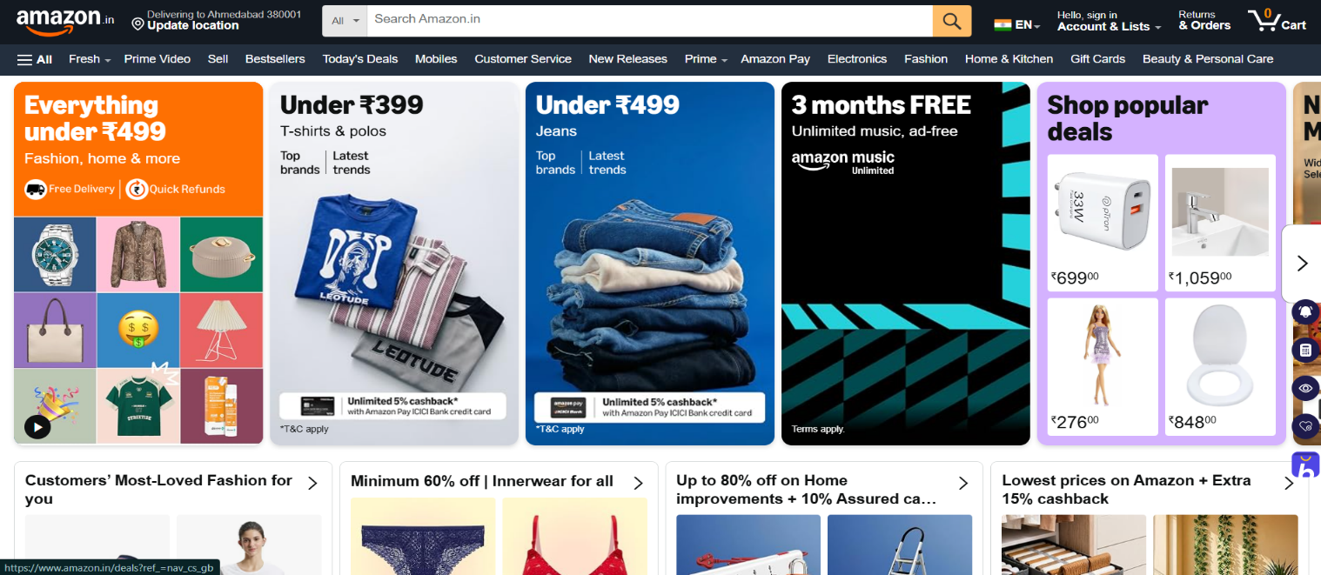

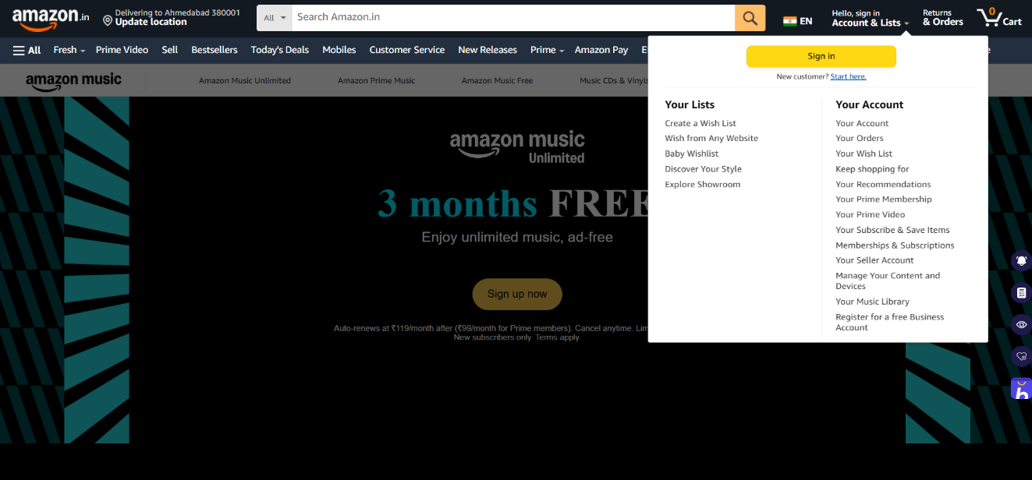
Step 2: Click Sign In

Step 3: Enter Email/Mobile number

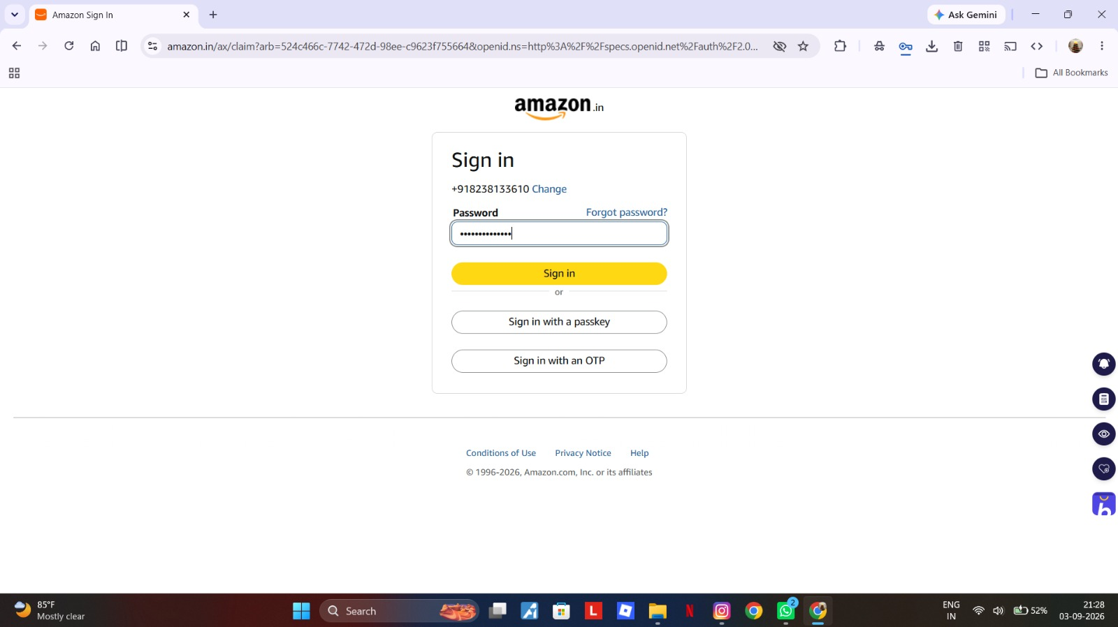
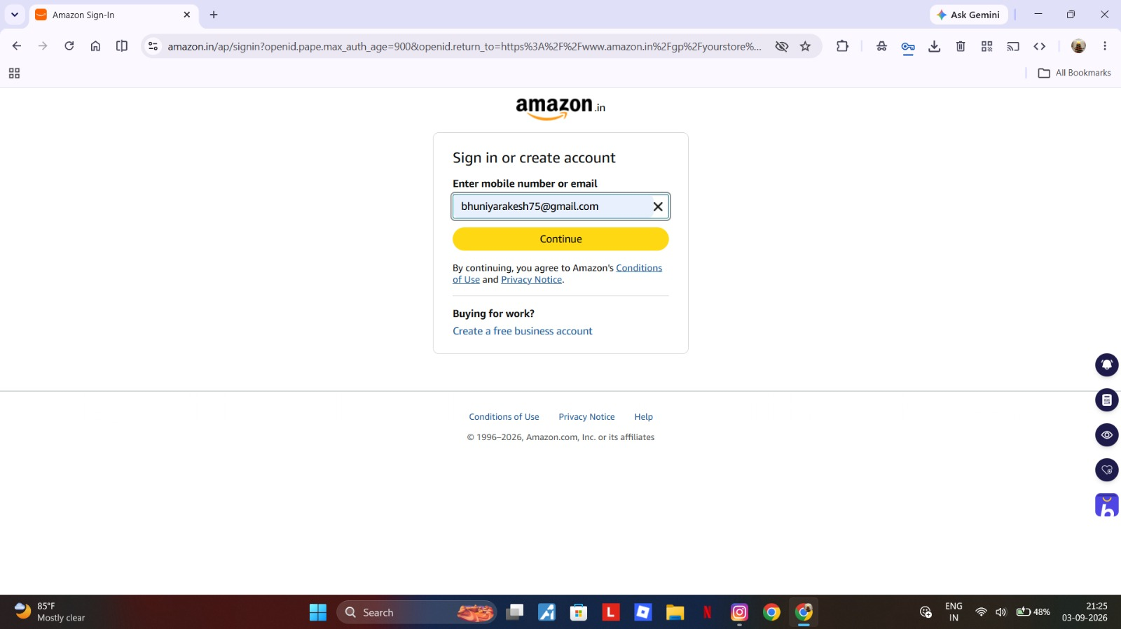
Step 4: Valid Password

Step 5: Click Sign In

